School Name
Mathematics Test 2017
Year 10 |  | Proportion | Non Calculator
Skills and Knowledge Assessed:  - Solve problems involving direct proportion. Explore the relationship between graphs and equations corresponding to simple rate problems (ACMNA208) |  |  | Name_________________
Section 1 Short Answer Section
Write all working and answers in the spaces provided on this test paper.

Water has been running from a tap at a rate of 1.2 litres/hour for a period of 8 hours.
How many litres of water has run from the tap?

……………………………………………………………………………………………....

……………………………………………………………………………………………….
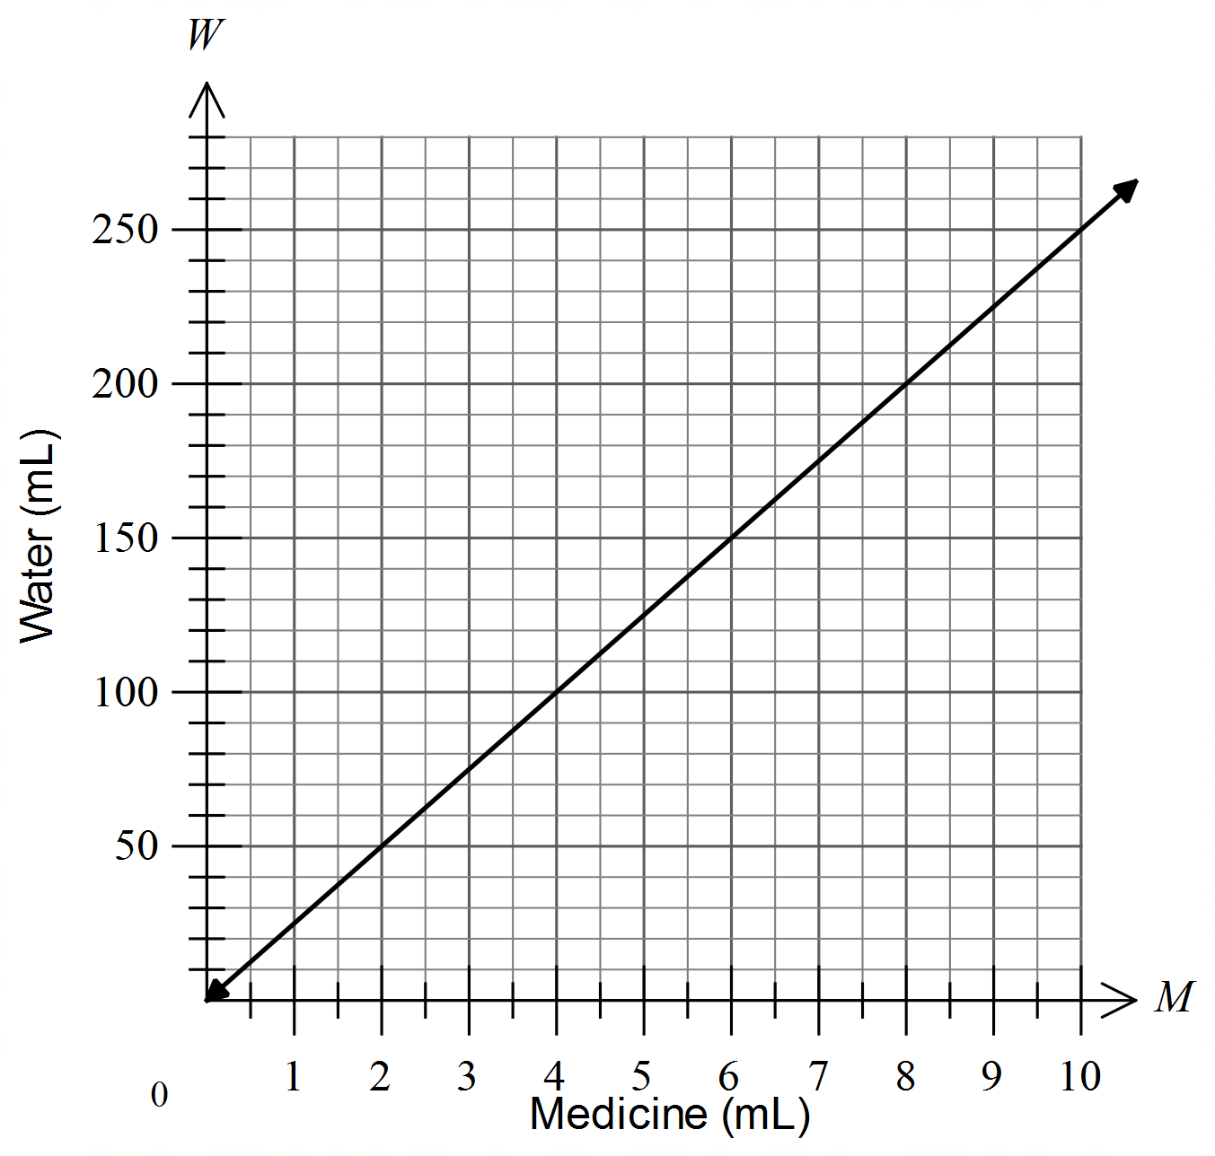Questions 2 and 3 refer to the following graph.
The graph shows the amount of water that needs to be mixed with a given amount of medicine, both measured in mL.

What amount of water would be needed for 6 mL of medicine?

……………………………………………………………………………………………....
Georgie mixes medicine with 200 mL of water. How much medicine did she take?

……………………………………………………………………………………………....
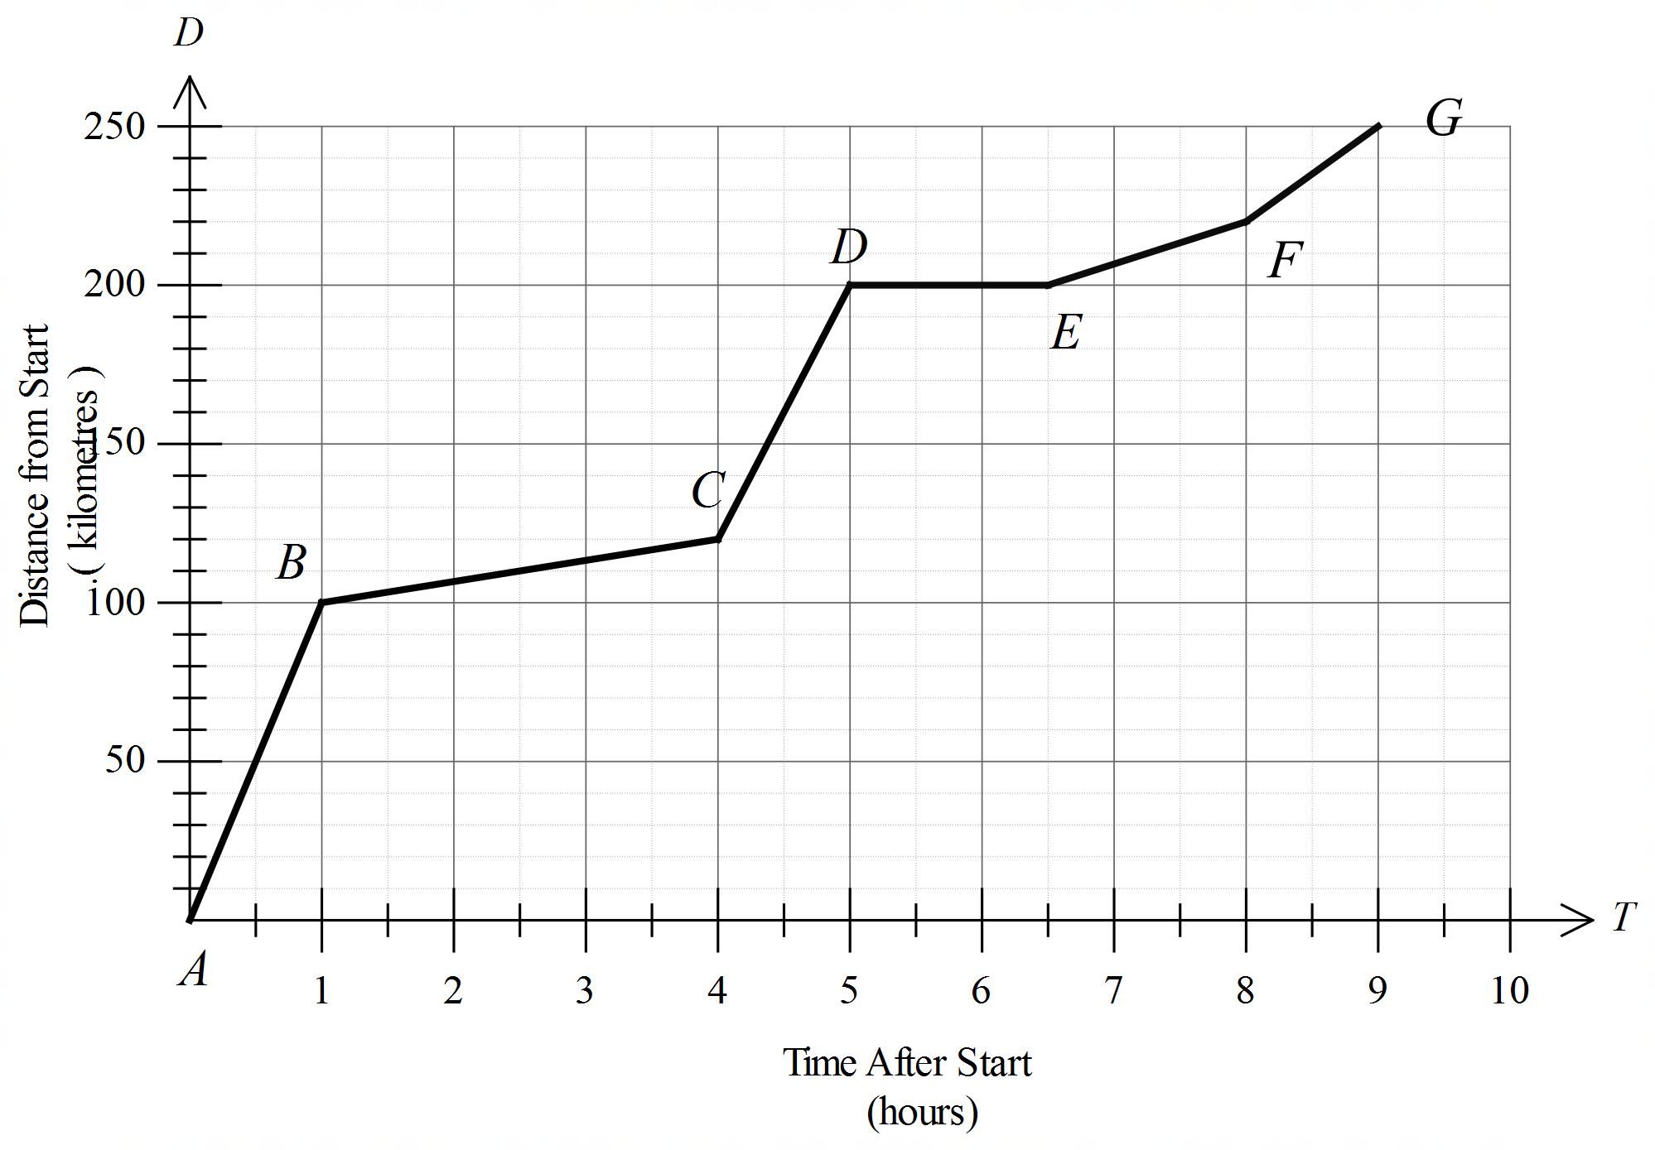Questions 4 and 5 refer to the following graph.
The distance/time graph shows a person travelling from point A to point G, passing through points B, C, D, E and F on the way.

The first part of the journey was by car and lasted for an hour. At what speed did the car travel?

……………………………………………………………………………………………....

……………………………………………………………………………………………….
How long after the start did the person stop, and for how long?

……………………………………………………………………………………………....

……………………………………………………………………………………………….
Between which two points did the person travel the slowest?

……………………………………………………………………………………………....

……………………………………………………………………………………………….
The cost of petrol bought from a service station is directly proportional to the number of litres bought.
Eight litres of petrol cost $12.00.
Write an equation for the cost ($C) of L litres of petrol.

……………………………………………………………………………………………....

……………………………………………………………………………………………….
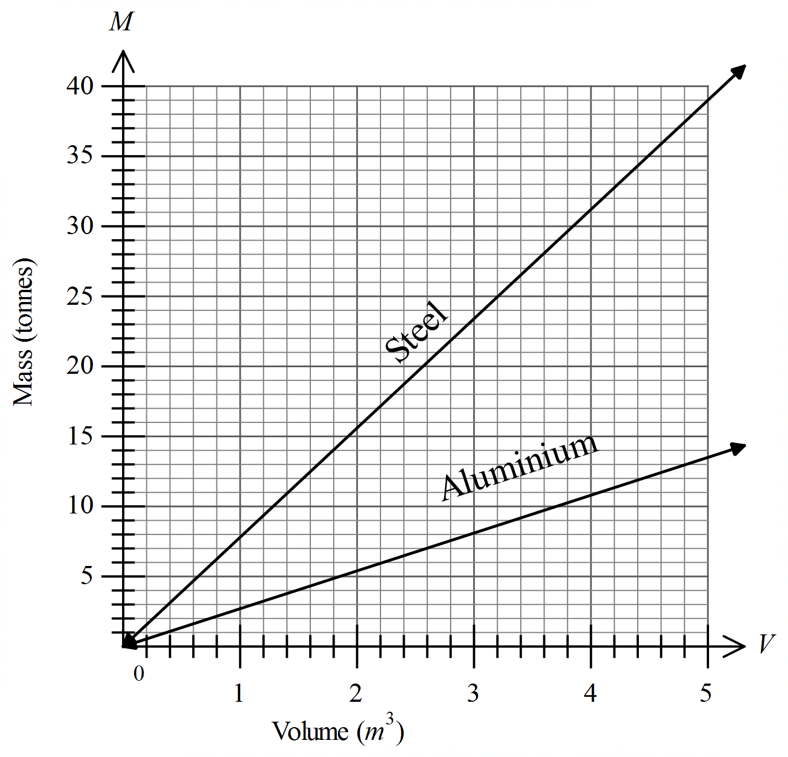Questions 8 – 10 refer to the following graph.
The graph shows the relationship between the Volume (V m³) and the Mass (M tonnes) of two metals (steel and aluminium) used in construction.

What is the mass of 4 m³ of aluminium?

……………………………………………………………………………………………….
John buys two identical metal beams which both have a volume of 3 m³.
If one beam is made of steel and of the other of aluminium, what is the difference in their masses?

……………………………………………………………………………………………....

……………………………………………………………………………………………….
What is the equation of the relationship between volume and mass for steel?

……………………………………………………………………………………………....

……………………………………………………………………………………………….
Questions 11 - 14 refer to the following:
In one day Marianne travels by car from her home in Melbourne to Minyip, which is 320 km away, and back again.
The travel graph summarises her journey.
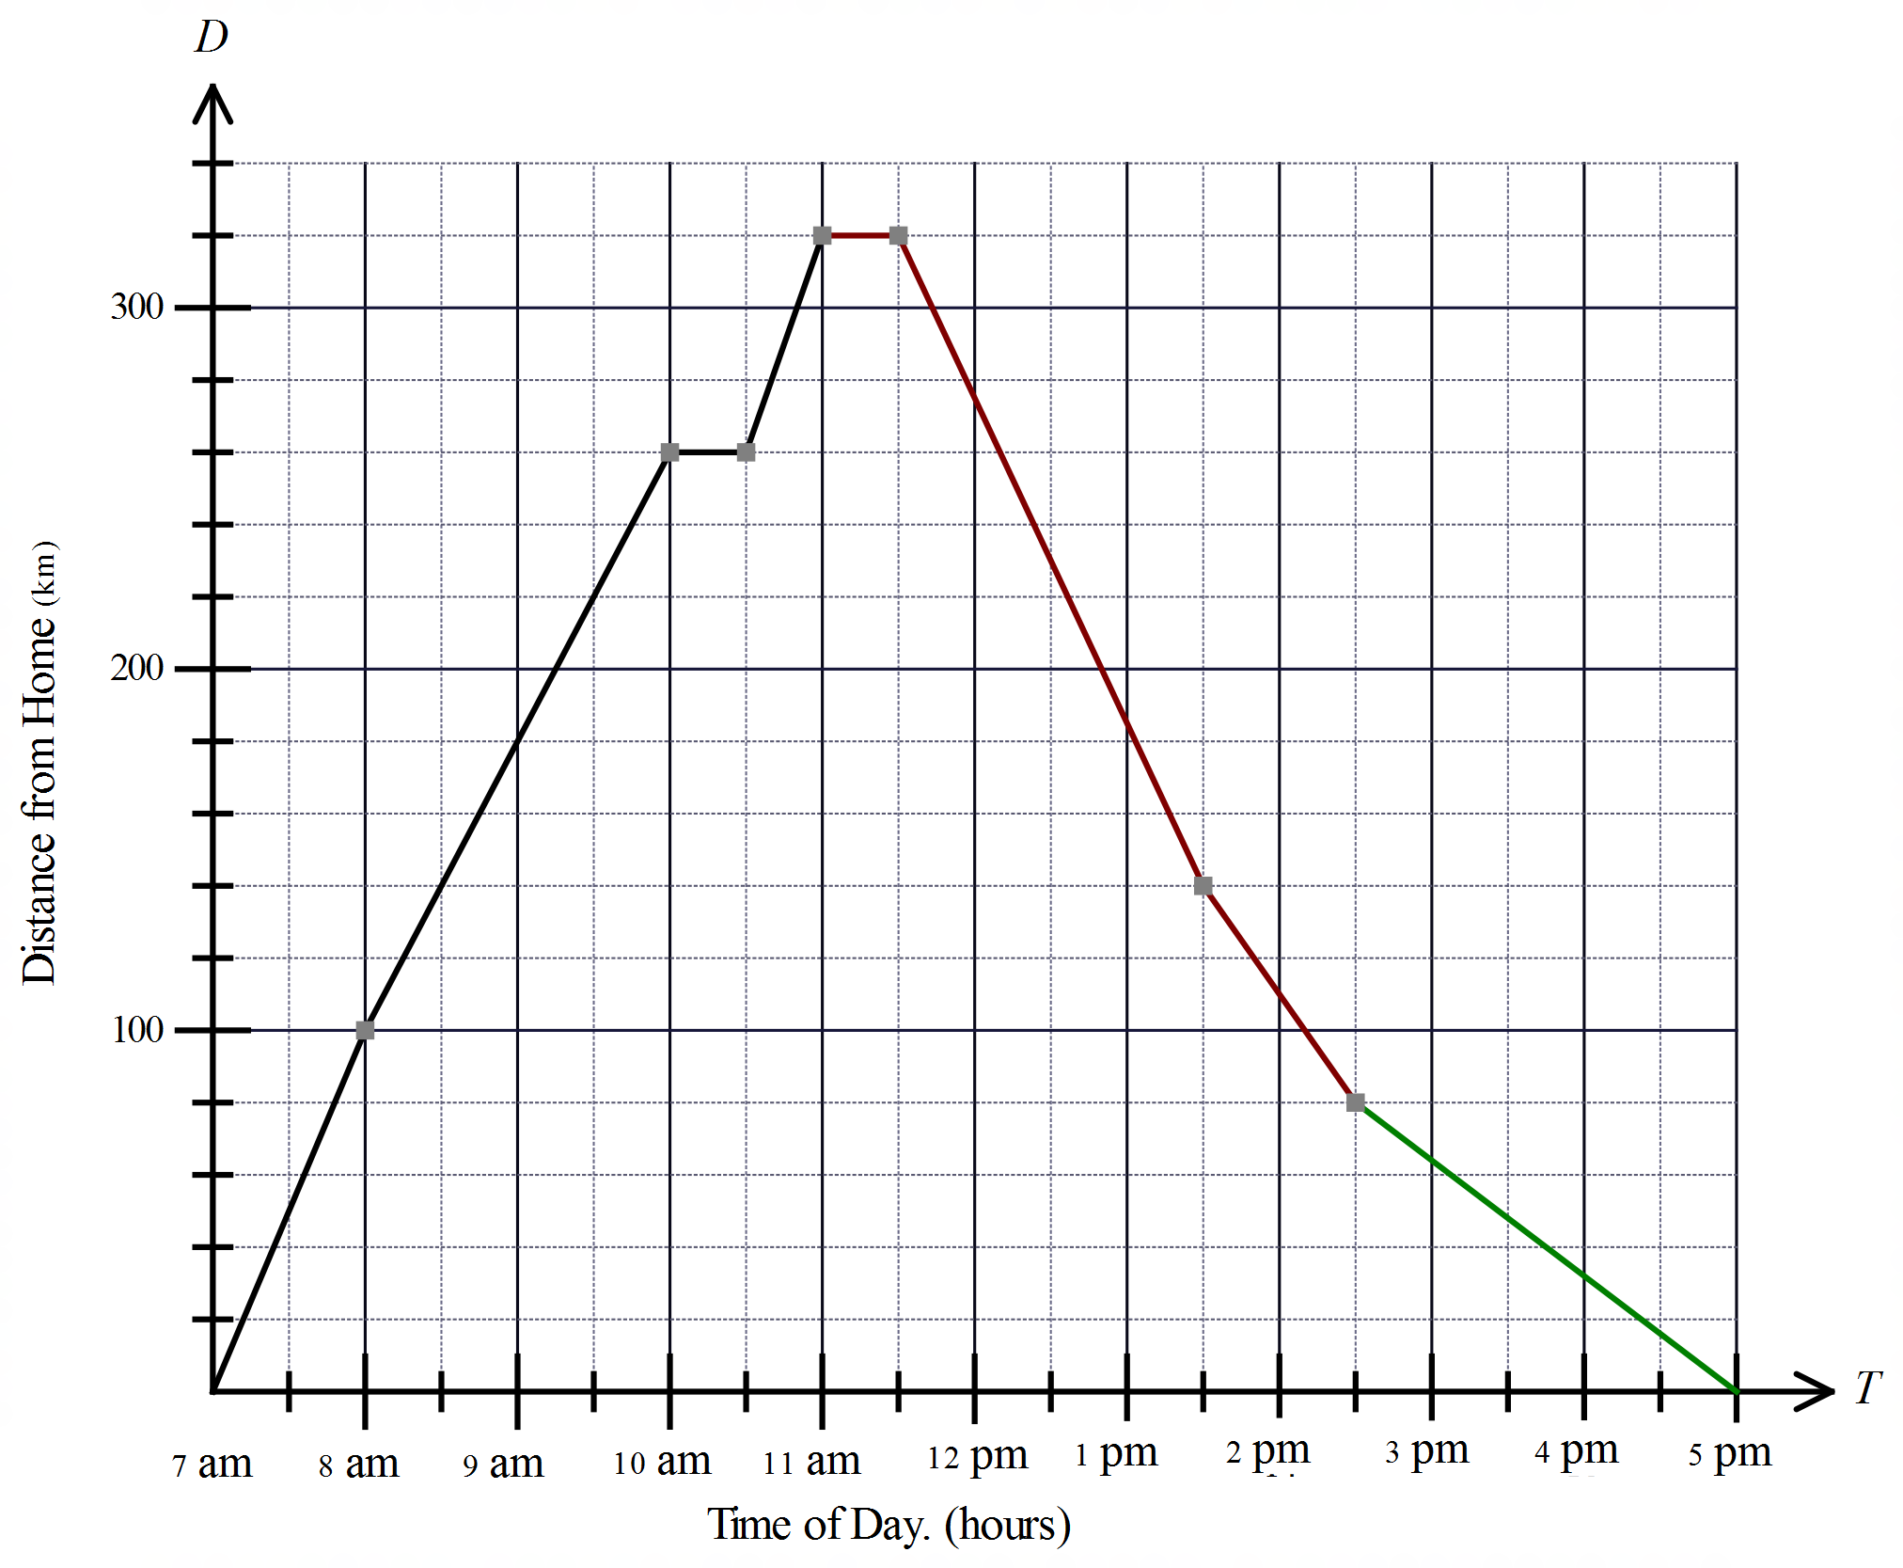

At what time did she arrive at her destination in Minyip?

……………………………………………………………………………………………….
At what speed did she travel between 8 am and 10 am?

……………………………………………………………………………………………....

……………………………………………………………………………………………….
At what time did she stop on her way to Minyip, and how long was she stopped for?

……………………………………………………………………………………………....

……………………………………………………………………………………………….
What was the slowest speed (apart from being stopped) that she travelled at during the journey?

……………………………………………………………………………………………....

……………………………………………………………………………………………….
Questions 15 and 16 refer to the following.
The Force (F Newtons) acting on an object is directly proportional to the acceleration (a m/s²) of the object.
The relationship can be represented by the equation  where m is the constant of proportion (corresponding to the mass of the object).

For a certain object, F = 120 when a = 12.5.
What is the value of the constant m?

……………………………………………………………………………………………....

……………………………………………………………………………………………….
For this same object, what force would be needed to produce an acceleration of 26 m/s²?

……………………………………………………………………………………………....

……………………………………………………………………………………………….
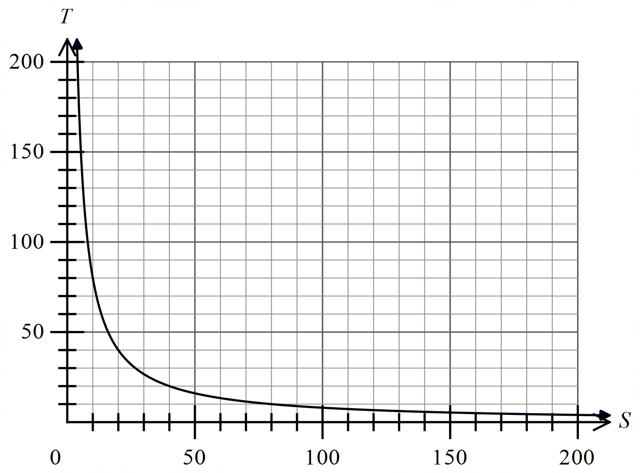Question 17 and 18 refer to the following graph.
The graph shows the time (in seconds) taken to transfer a given packet of data as the internet speed (in Gbps) increases.

If the packet needs to be transferred in 30 seconds or less, what is the minimum speed needed?
……………………………………………………………………………………………....

……………………………………………………………………………………………….
The equation that describes the relationship between the speed and the time is of the form 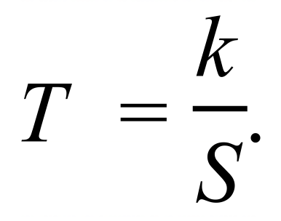
Find the value of k and write the equation for the relationship.

……………………………………………………………………………………………....

……………………………………………………………………………………………….

School Name
Mathematics Test 2017
Year 10 |  | Proportion | Calculator Allowed
 |  | Proportion | Name_________________
Section 2 Multiple Choice Section
Mark all your answers on the accompanying multiple choice answer sheet, not on this test paper. You may do any working out on this test paper. Calculators are allowed for this section.

A truck consumes 0.5 litres/km when on a journey. How many kilometres was the journey is the truck consumed 480 litres of fuel?

A. 120 km B. 240 km C. 960 km D. 1920 km
The increase in depth (D cm) of water in a tank is directly proportional to the amount (A mm) of rain that falls on a roof feeding the tank.
Which equation could describe this proportion?

A.  B. 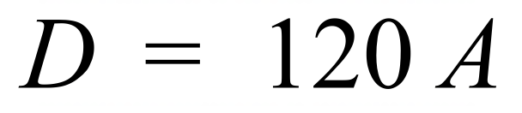 C. 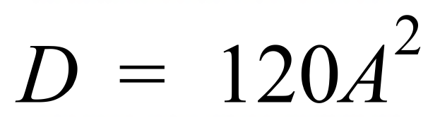 D. 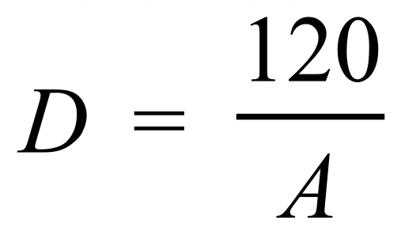
Questions 2 and 3 refer to the following graph.
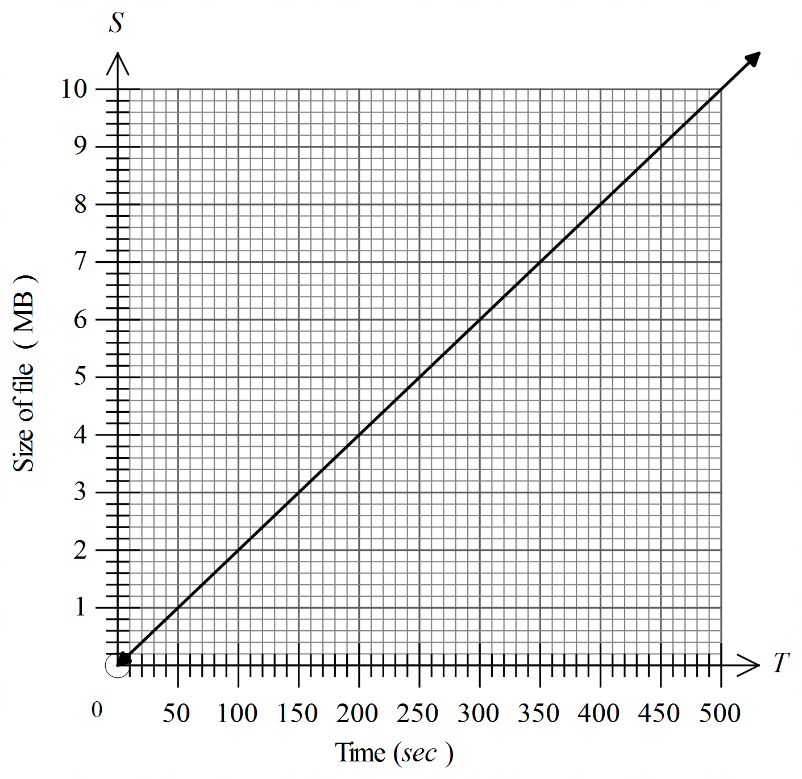The graph shows the size of a file (S MB) required to record an instrumental track of of given duration (T seconds).

What sized file would be needed for a track that lasted 5 minutes?

A. 3 MB B. 4 MB C. 5 MB D. 6 MB
What is the equation which describes the proportion?

A.  B.  C.  D. 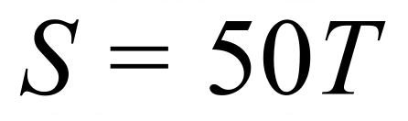
Questions 5 and 6 refer to the following graph.
The graph shows the audience size at a play, from the time the doors were opened until the last audience member leaves.
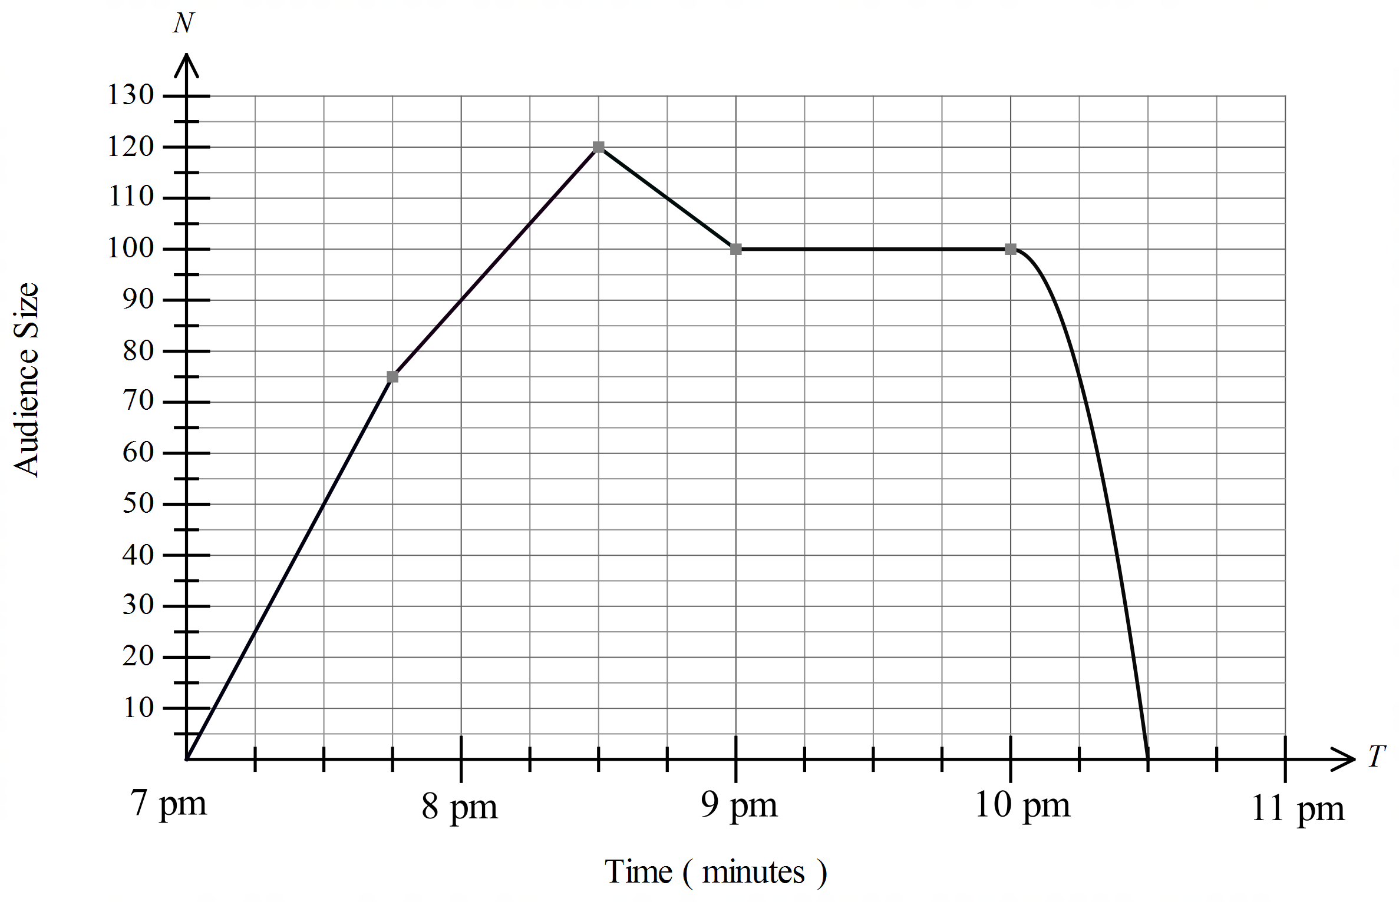

Between what times is the audience size decreasing at an increasing rate?

A. 7:00 and 7:45 B. 7:45 and 8:30 C. 8:30 and 9:00 D. 10:00 and 10:30
What was the fastest rate at which the audience size was increasing?

A. 50 people /hour B. 75 people /hour
C. 100 people /hour D. 150 people /hour
Questions 7 – 9 refer to the following graph.
The distance/time graph shows Sarah’s day out where she visited three of her friends, Taylah, Ursula and Vanessa in that order, then returned home.
.
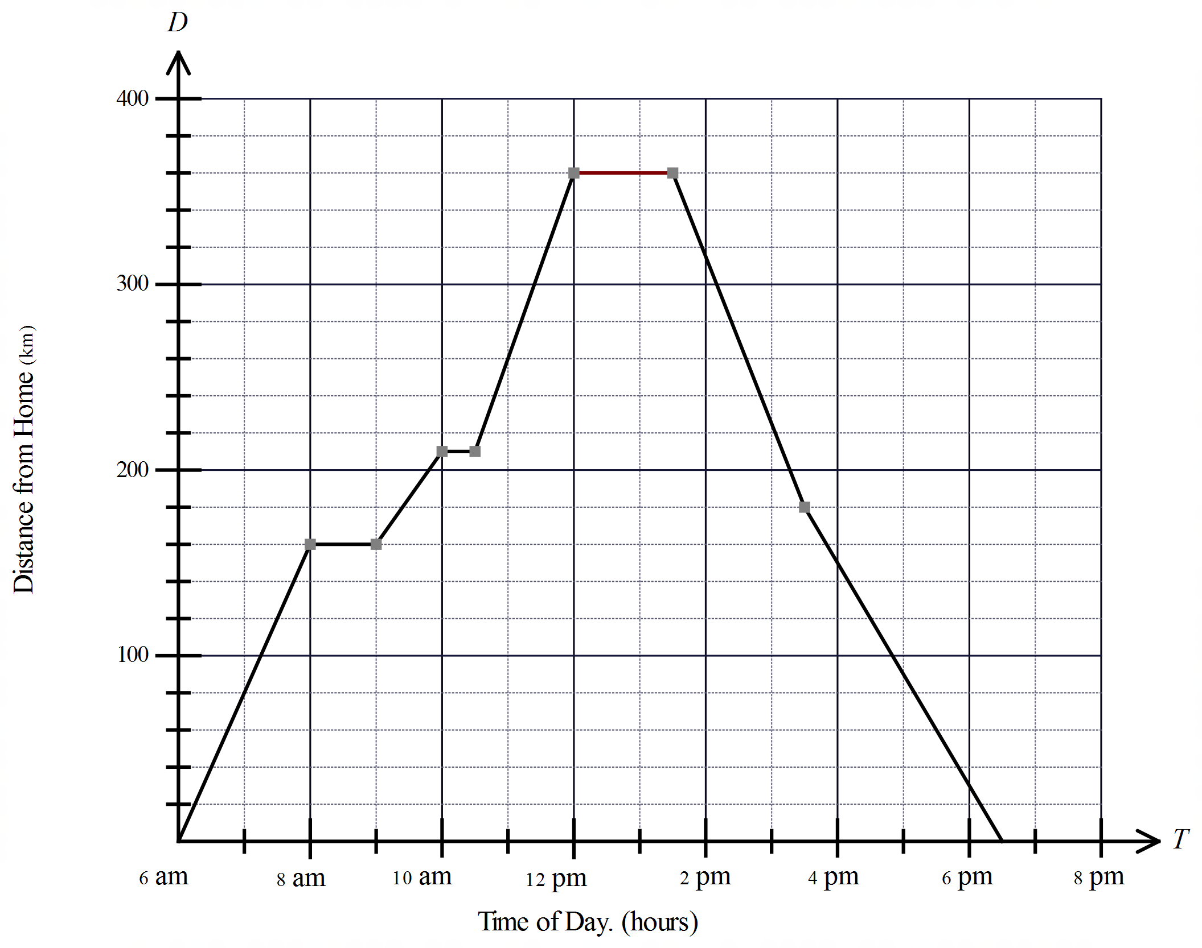

She only stopped to visit her friends.
Which friend did she spend the shortest time visiting?

A. Taylah B. Ursula C. Vanessa D. She spent the same time with each.
At what speed did she travel between 10:30 am and 12:00pm?

A. 75 km/h B. 80 km/h C. 90 km/h D. 100 km/h
How far did Sarah travel in the day?

A. 360 km B. 450 km C. 720 km D. 900 km
The length (L) of a highway sealed by an asphalt laying apparatus is directly proportional to the time (T) that the apparatus has been working for.
When the apparatus has been working for 8 hours it will seal 40 m of highway.
Which equation describes the relationship between L and T.

A. 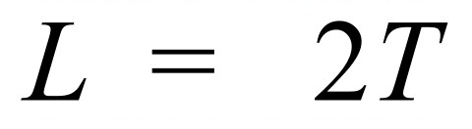 B. 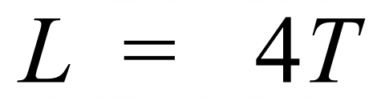 C.  D. 
The quantities P and Q are in direct linear proportion. Which graph illustrates this proportion?

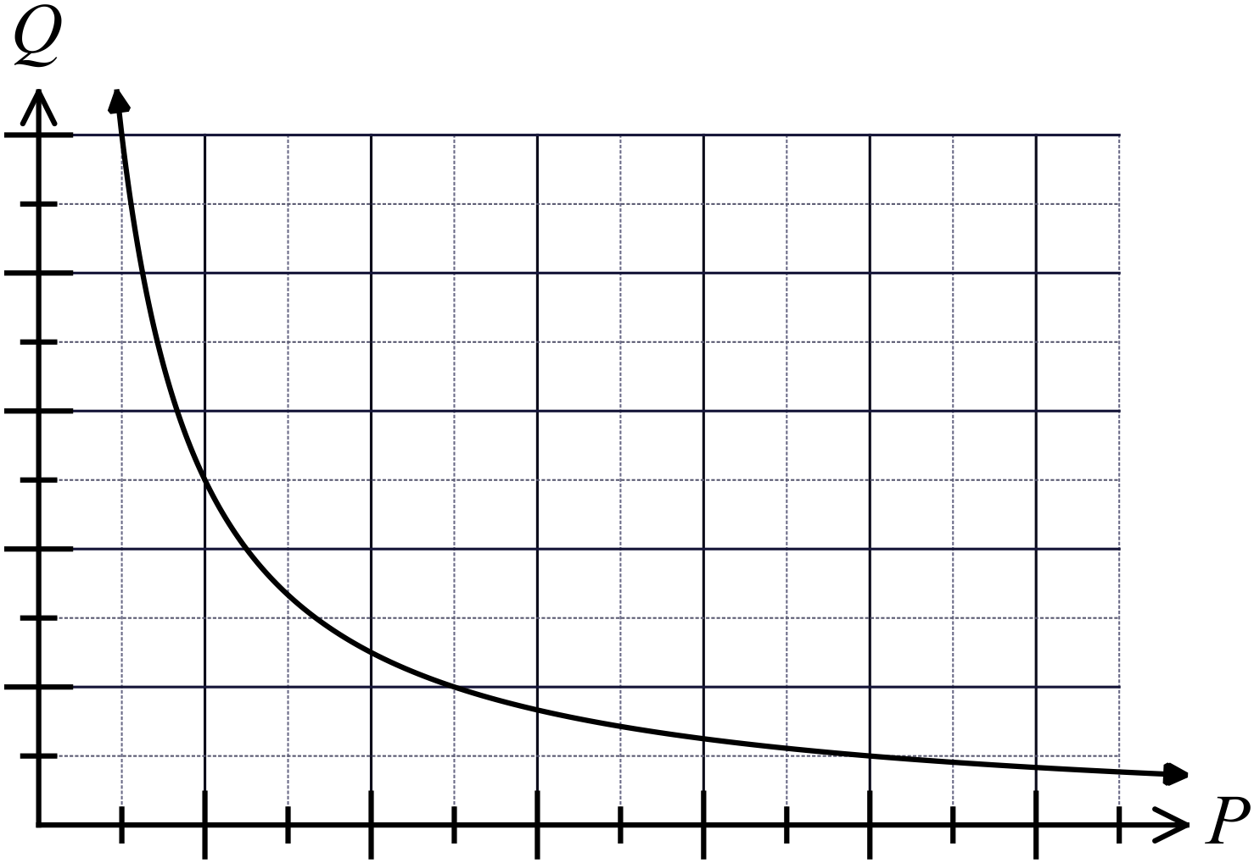A. B.
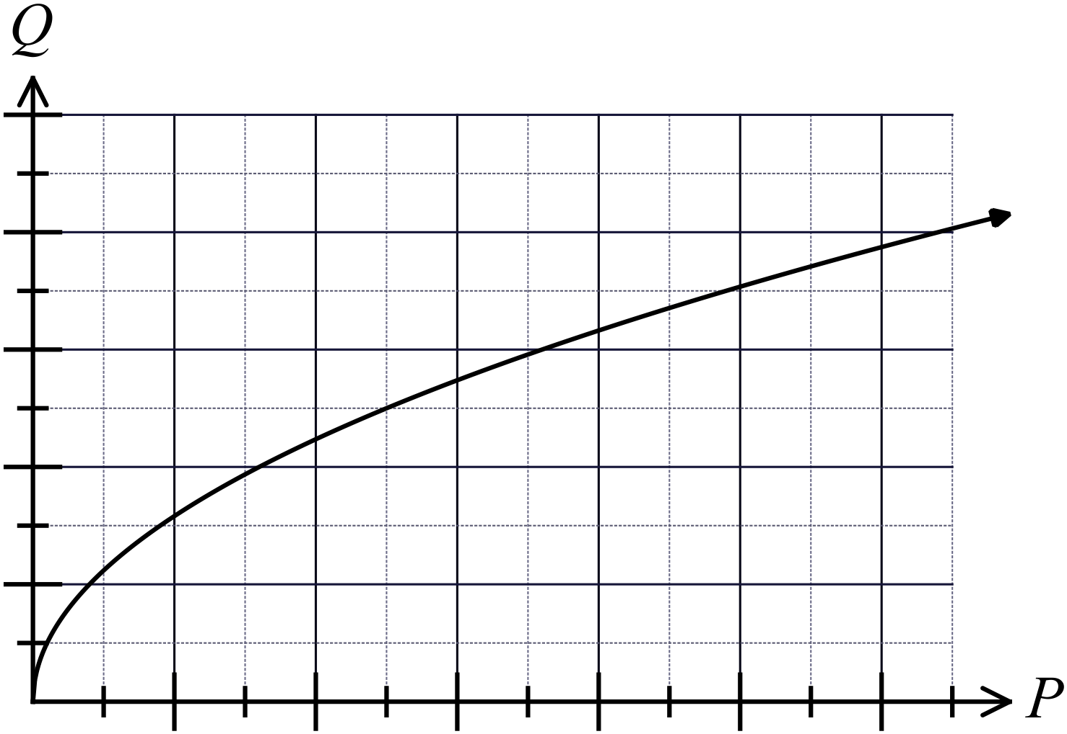

C. D.
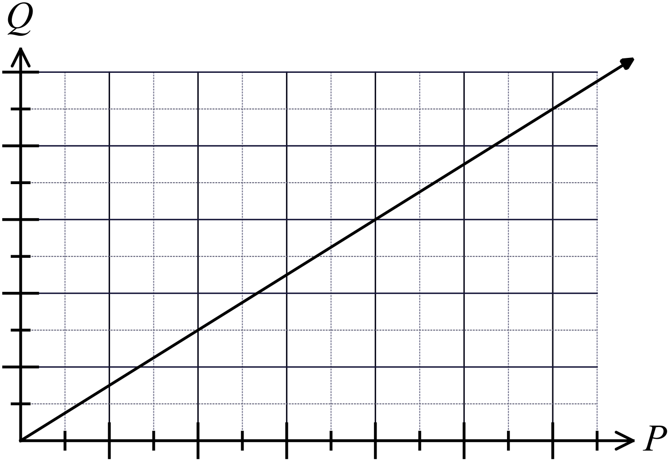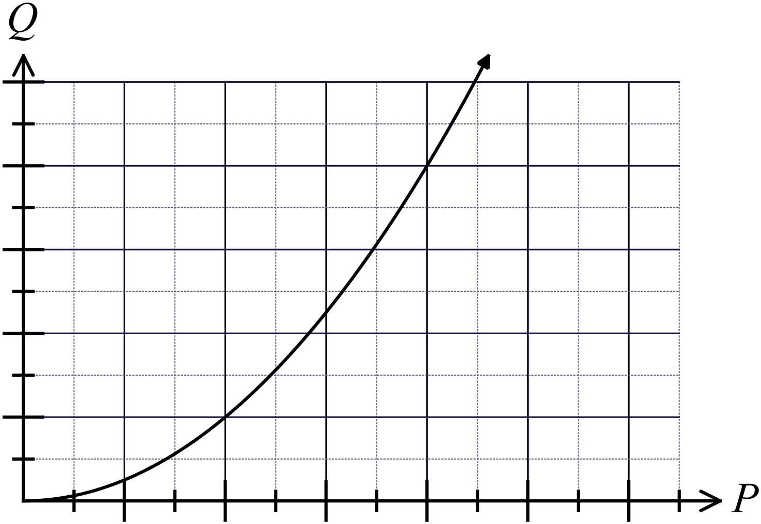

In which of these graphs is y decreasing at a decreasing rate as x increases?
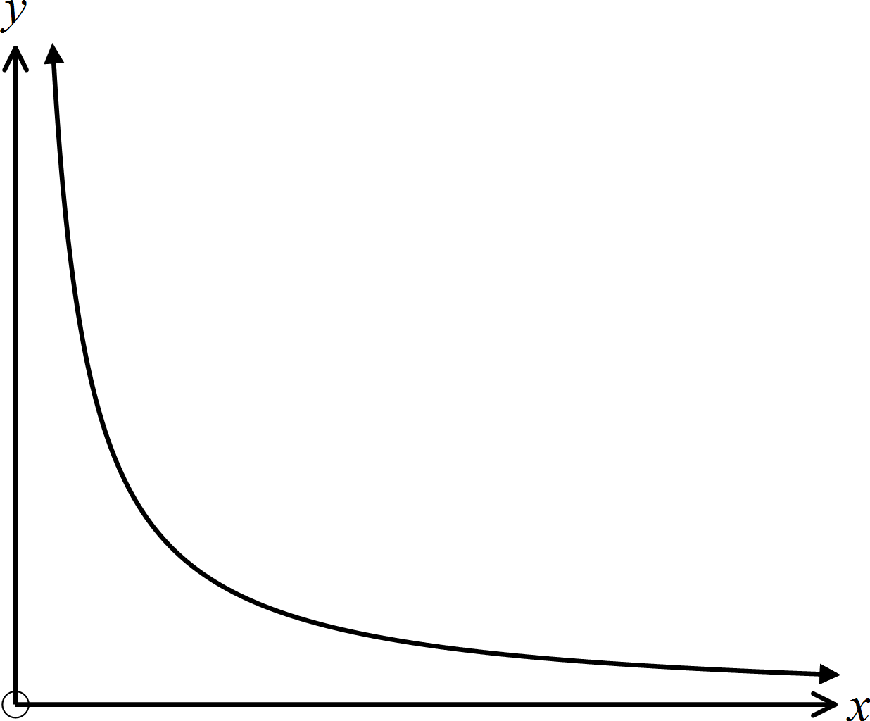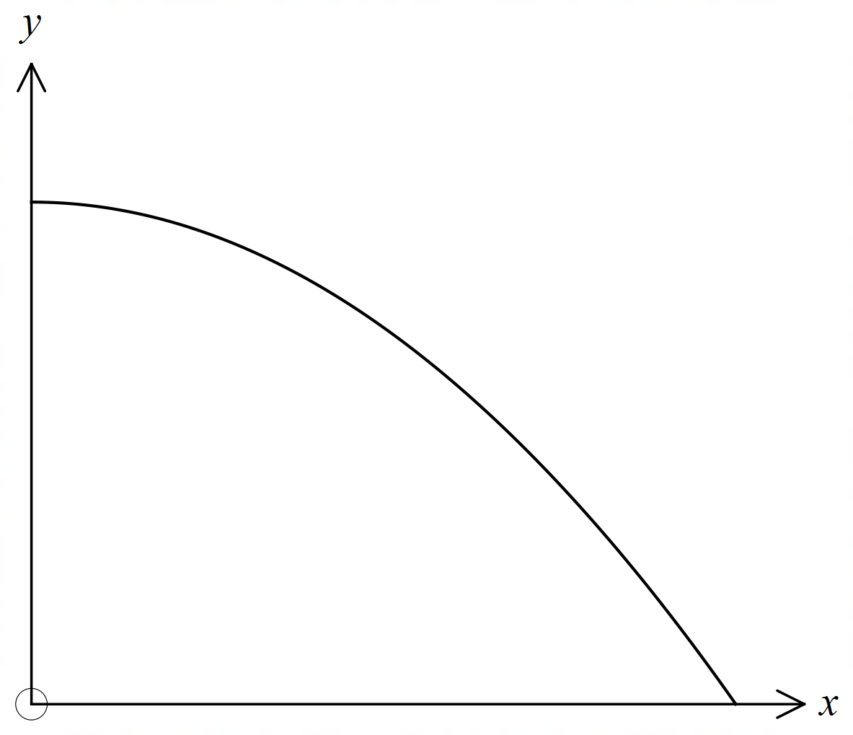 A. B.

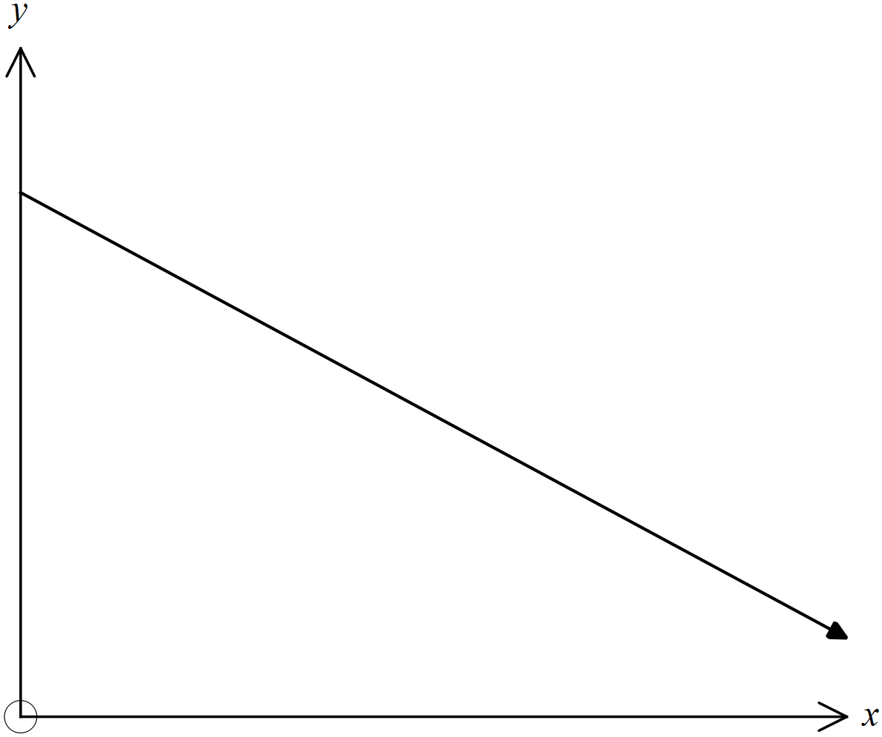C. D.
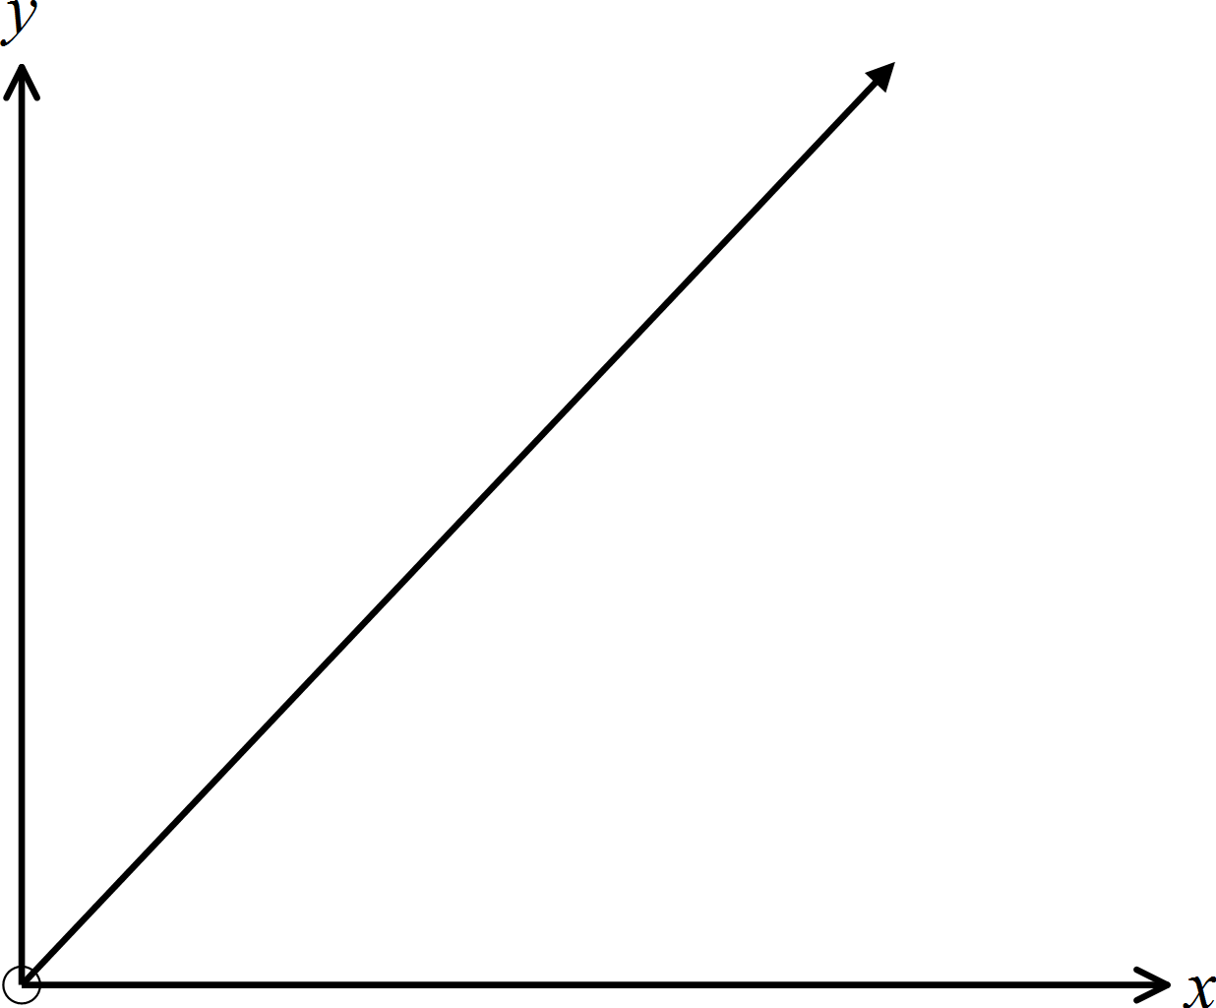

The time (T) taken to spread 5 tonnes of topsoil is inversely proportion to the number of people (N) who are helping.
Which of these could be the equation that describes this relationship?

A.  B. 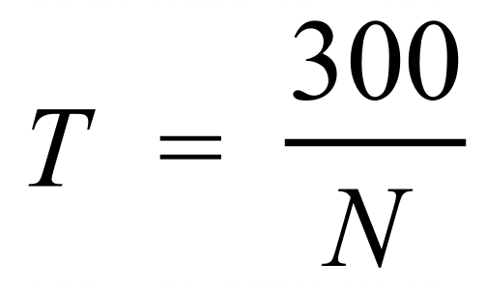 C. 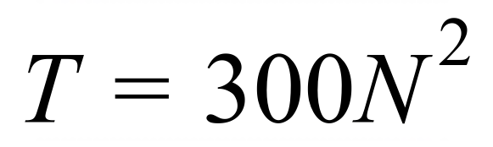 D. 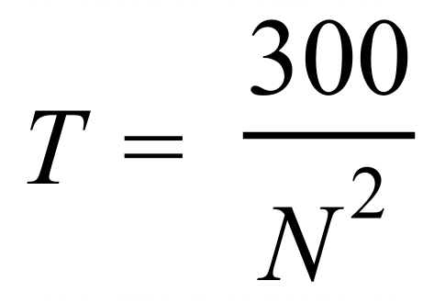
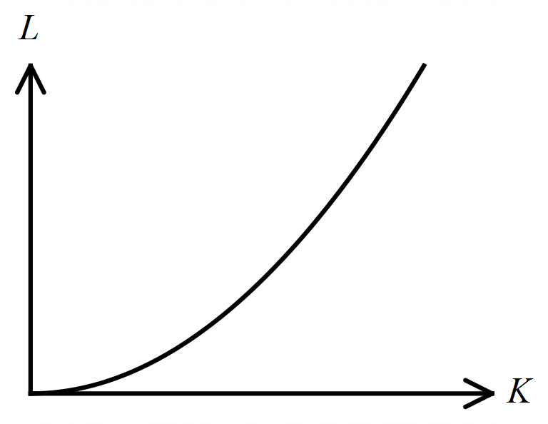The graph shows the relationship between L and K.

A. L is decreasing at a decreasing rate relative to K.
B. L is decreasing at an increasing rate relative to K.
C. L is increasing at a decreasing rate relative to K.
D. L is increasing at an increasing rate relative to K.

Water is poured into a symmetrical container which has a horizontal cross section which is a circle of varying diameters.
The graph below shows the rate at which the level of water increased in the container.
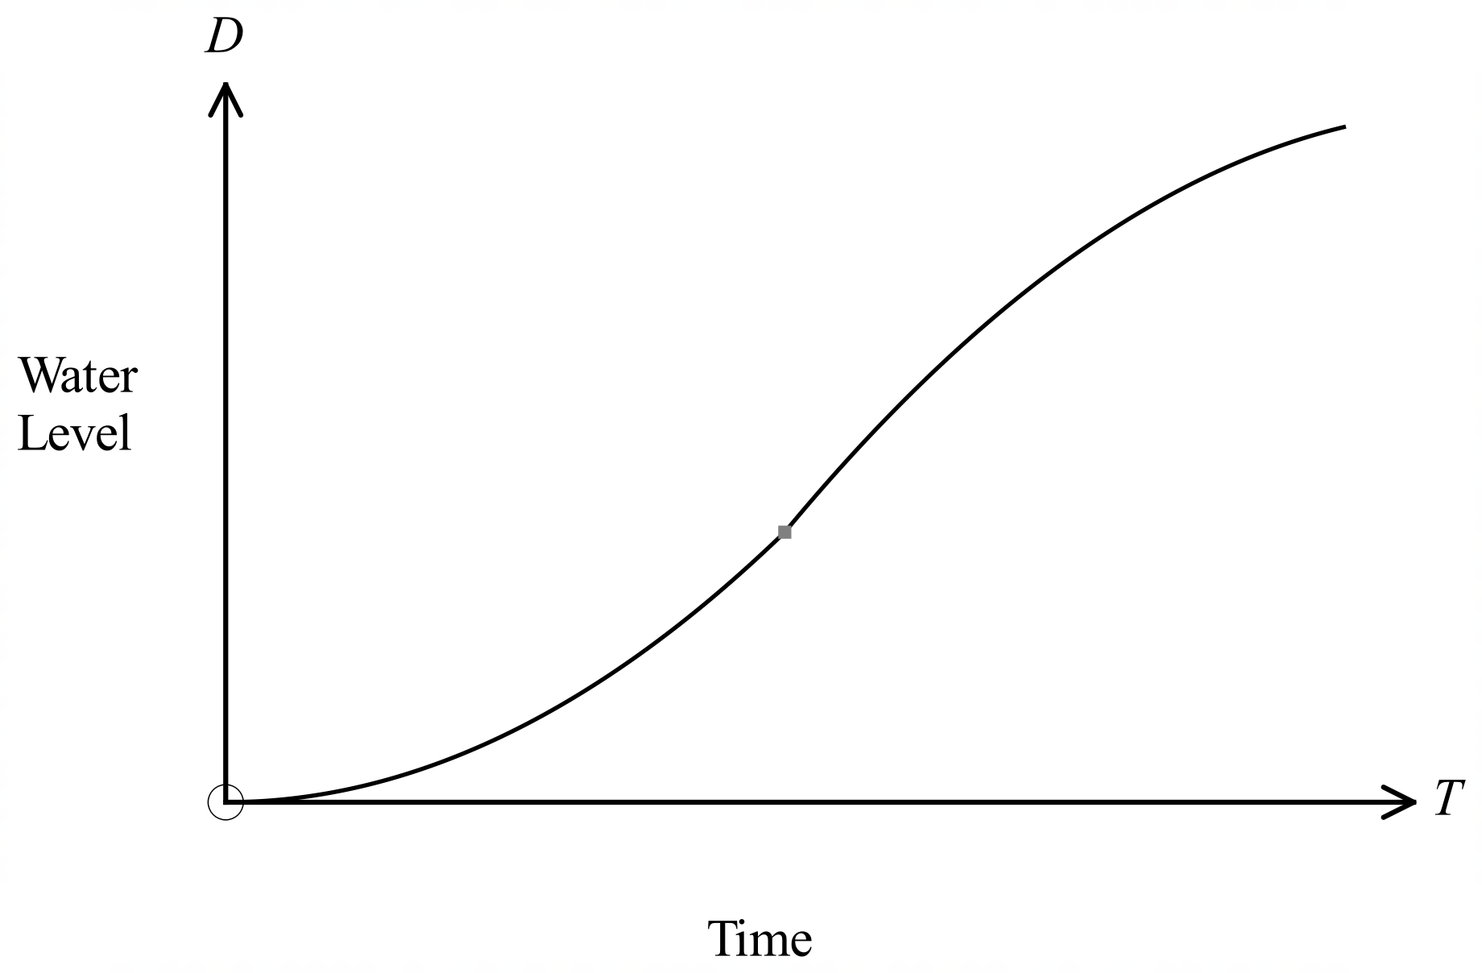

Which diagram shows the vertical cross section of the container?

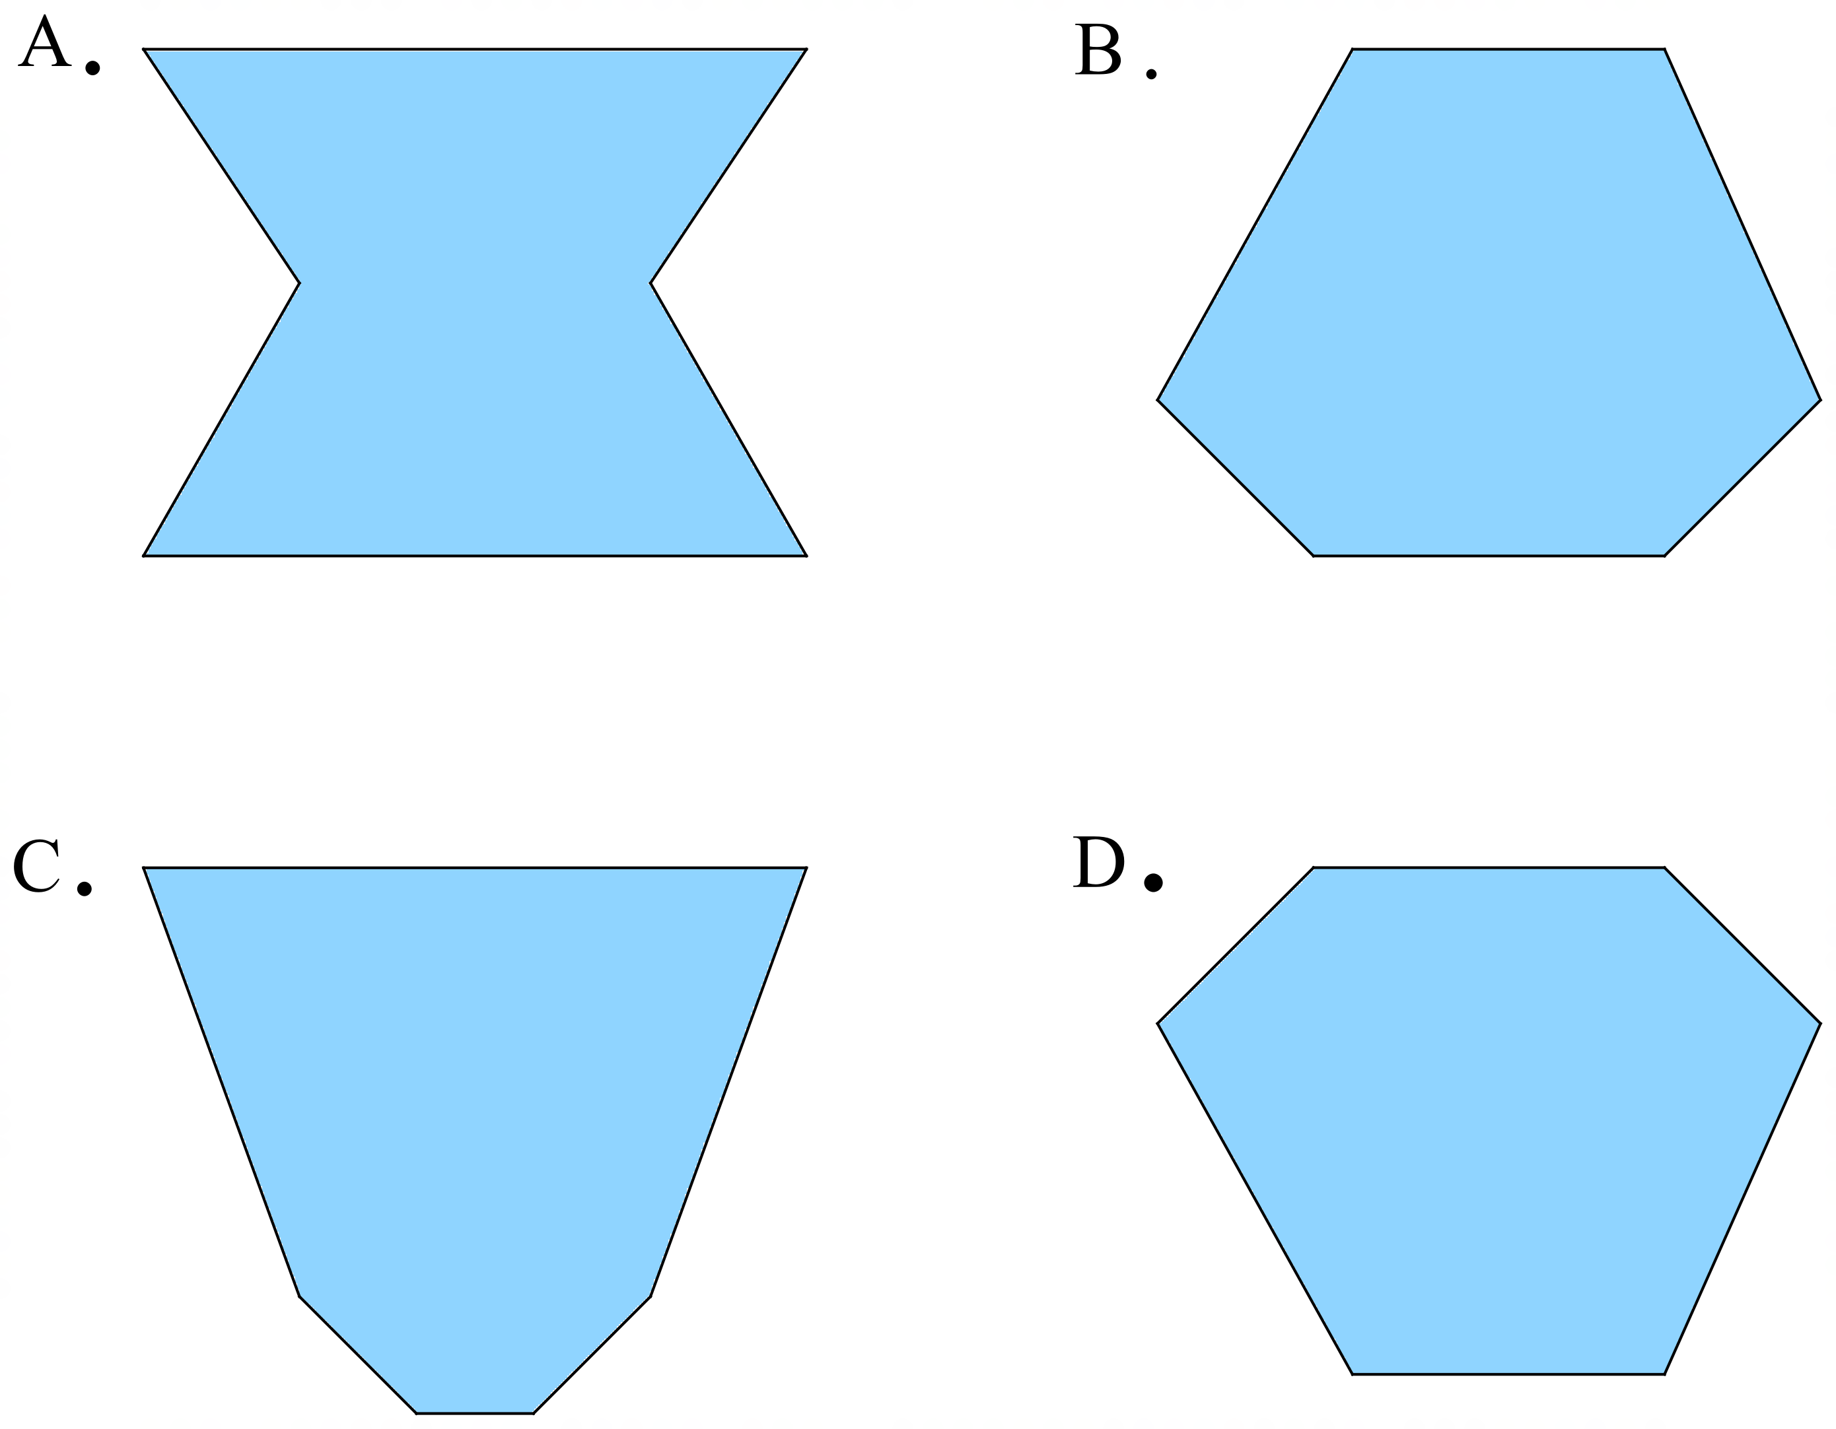

School Name
Mathematics 2017
Multiple Choice Answer Sheet
Proportion
Name _____________________________________________
Completely fill the response oval representing the most correct answer.
1. A B C D
2. A B C D
3. A B C D
4. A B C D
5. A B C D
6. A B C D
7. A B C D
8. A B C D
9. A B C D
10. A B C D
11. A B C D
12. A B C D
13. A B C D
14. A B C D
15. A B C D

School Name
Mathematics Test 2017
Year 10 | Proportion | Non Calculator Section
ANSWERS

Question | Working and Answer
 | 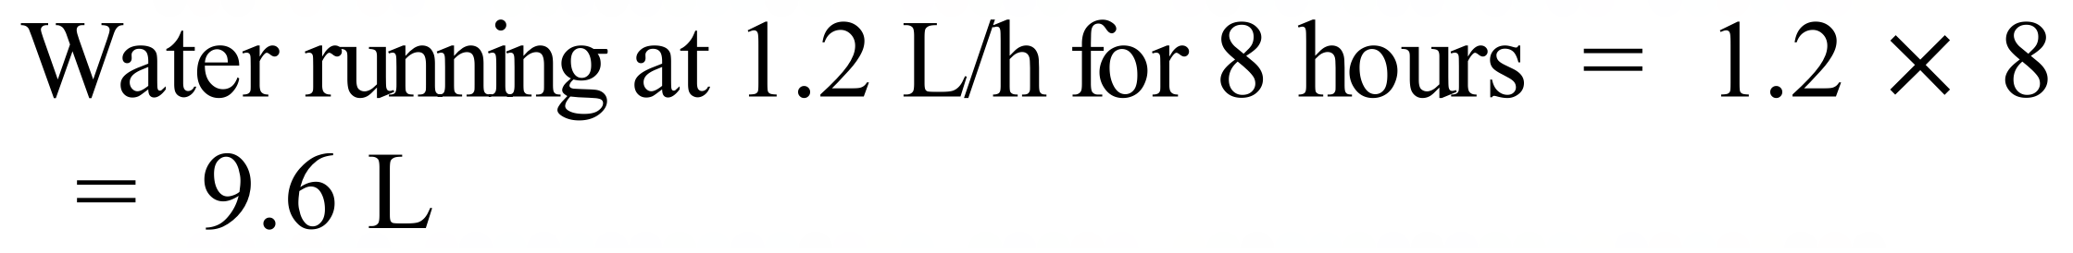
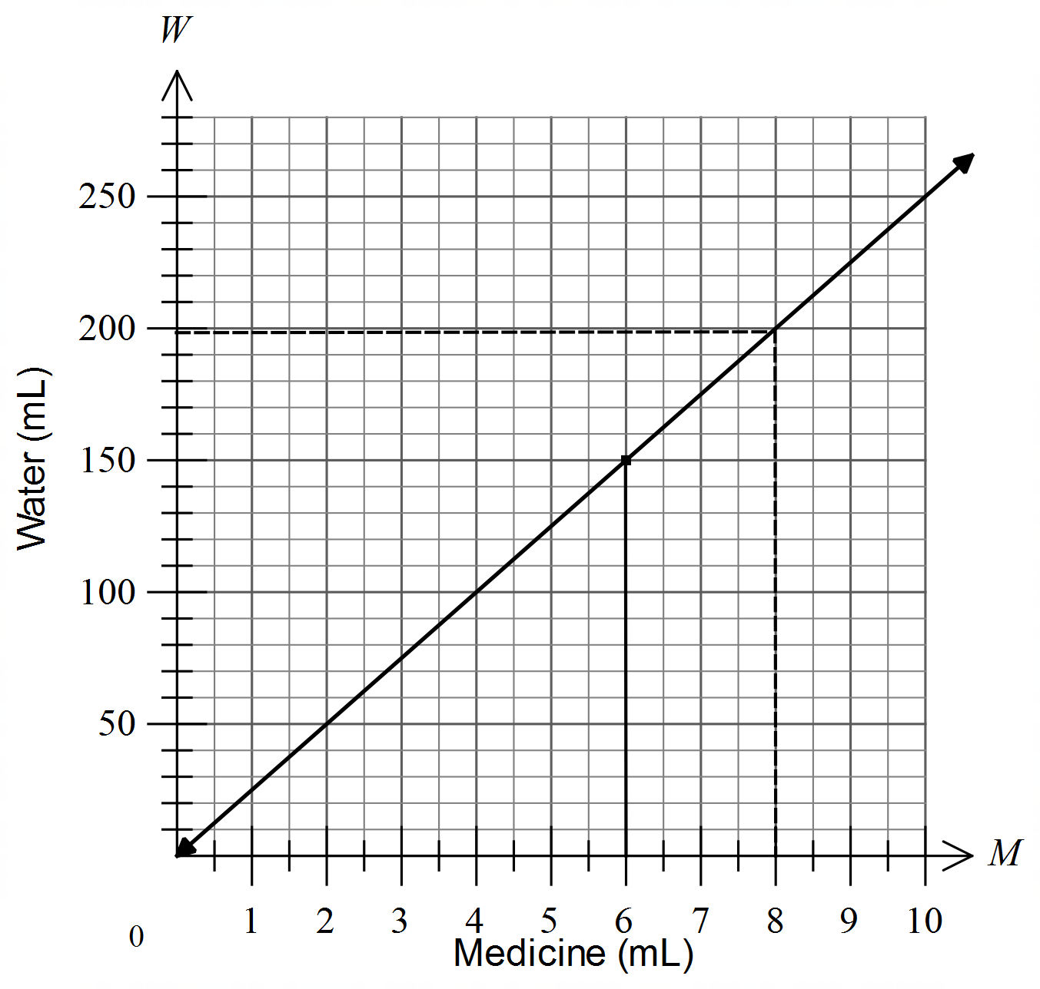

When M = 6, W = 150 mL from graph (unbroken line _____)
 | When W = 200, M = 8 from graph (broken line ------)
 | Between A and B it travelled 100 km in 1 hour so speed = 100 km/h.
 | Stopped when the graph is horizontal, so stopped after 5 hours and remained stopped for 1½ hours.
 | Lowest slope on the graph is the slowest, so between B and C
 | 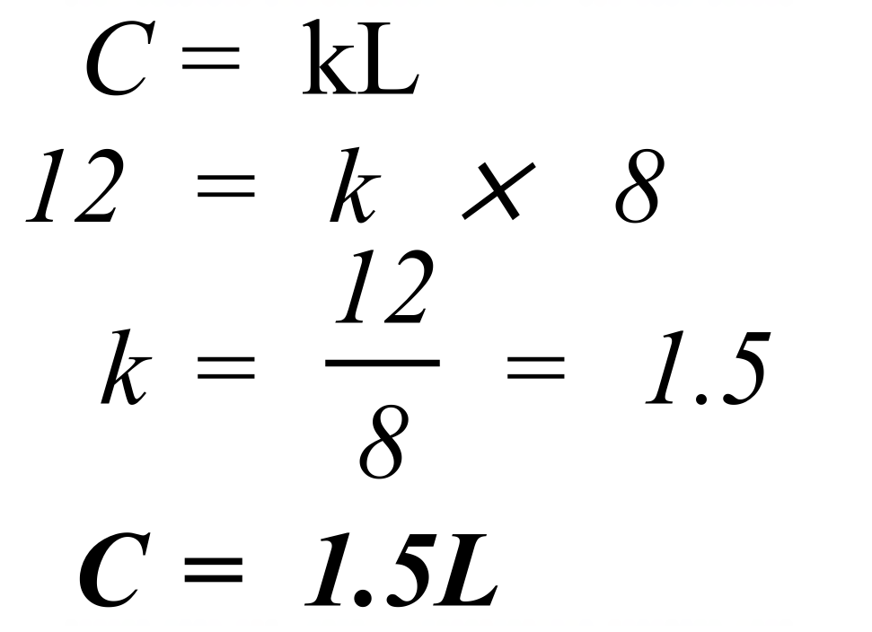
 | Mass of 4 m³ of Aluminium  11 tonnes.
Mass of 3 m³ of Aluminium 8 tonnes.
Mass of 3 m³ of Steel 23.5 tonnes.
Difference in masses 23.5 – 8 15.5 tonnes.
 | 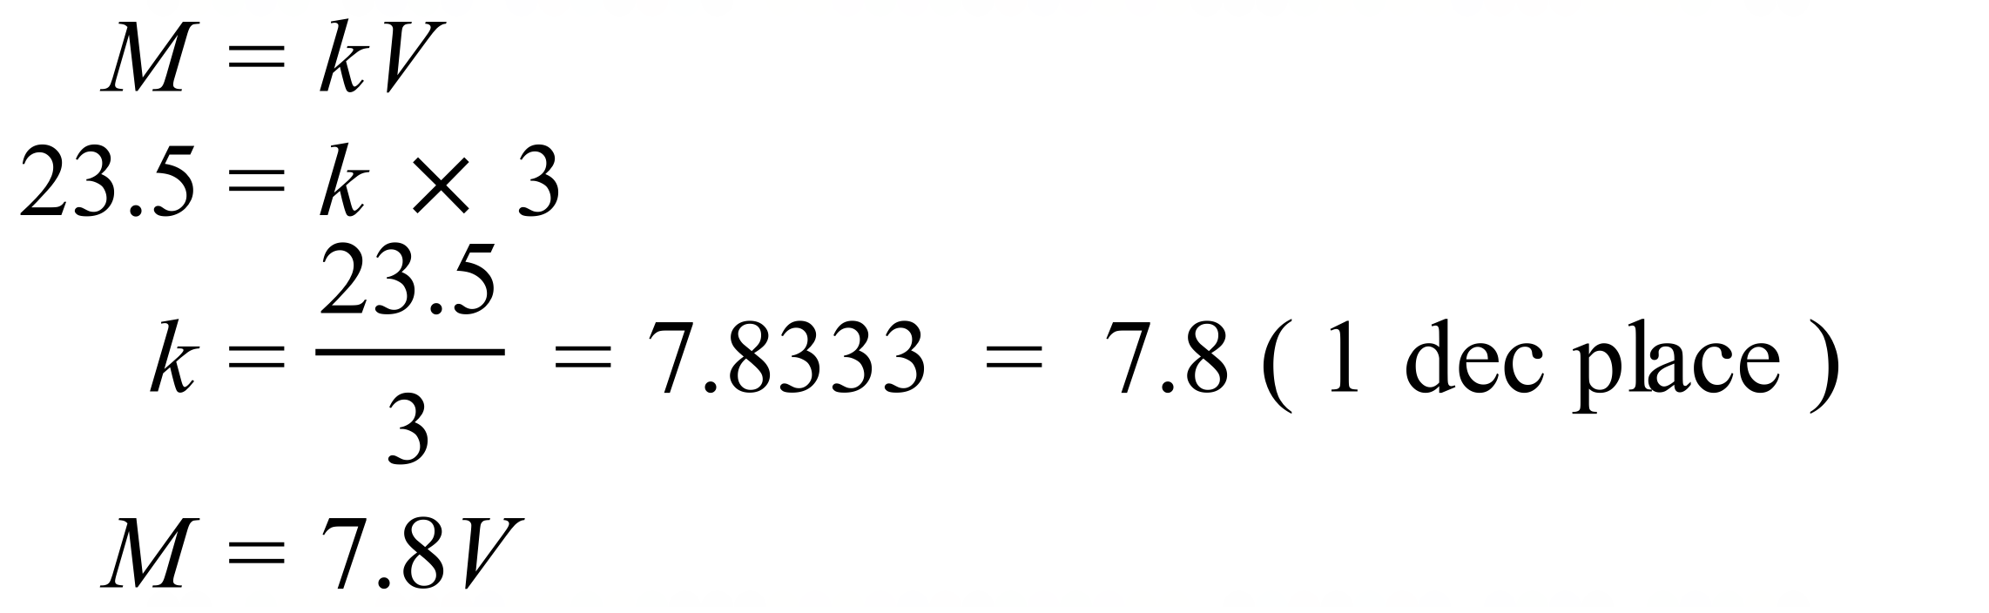
 | She arrived at 11 am.
At 8 am she is 100 km from home and at 10 am she is 260 km from home.
SO she has travelled 160 km in 2 hours.
Speed = 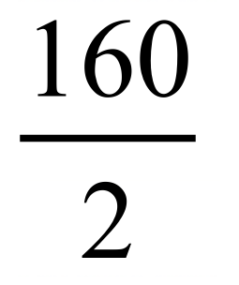 = 80 km/h
 | Horizontal section indicates stopped, so she stopped at 10 am for half an hour.
Slowest speed is the shallowest gradient on the graph which appears to be between 2:30 pm and 5 pm.
Distance travelled = 80 km
Time taken = 2.5 hours
Speed = 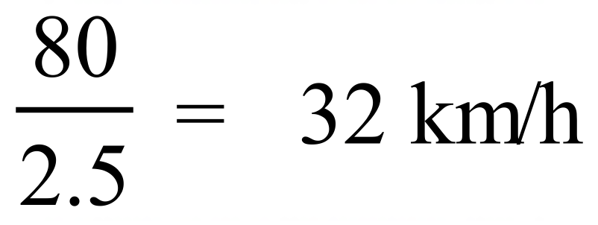
 | 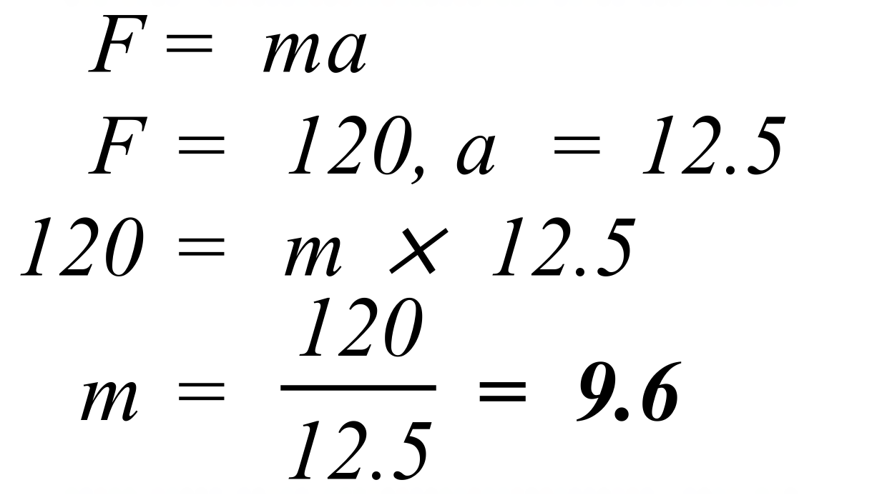
 | 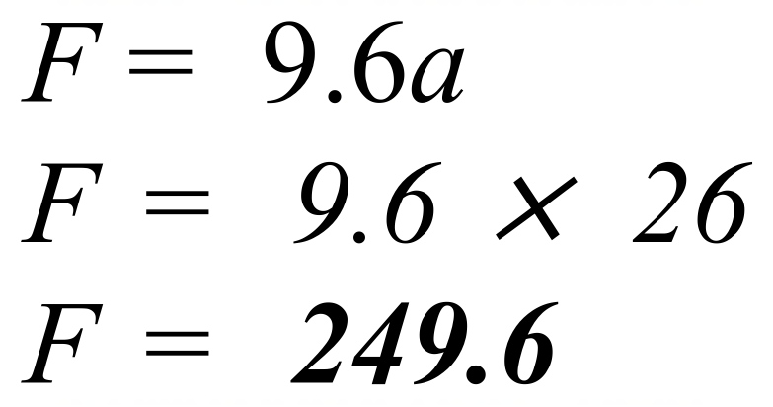
 | From the graph 30 sec corresponds to about 27 Gbps. (accept 26 – 28)
 | 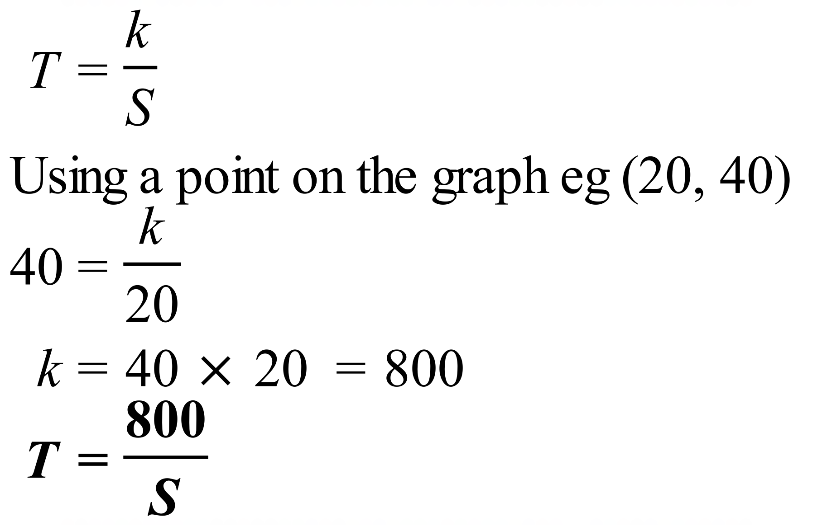

School Name
Mathematics Test 2017
Year 10 | Proportion | Calculator Allowed  Multiple Choice  Section

ANSWERS

Question | Working | M C Answer
 | Uses 0.5 L/km so used 1 litre to travel 2 km.  Used 480 L so travelled 480 × 2 = 960 km. | C
 | 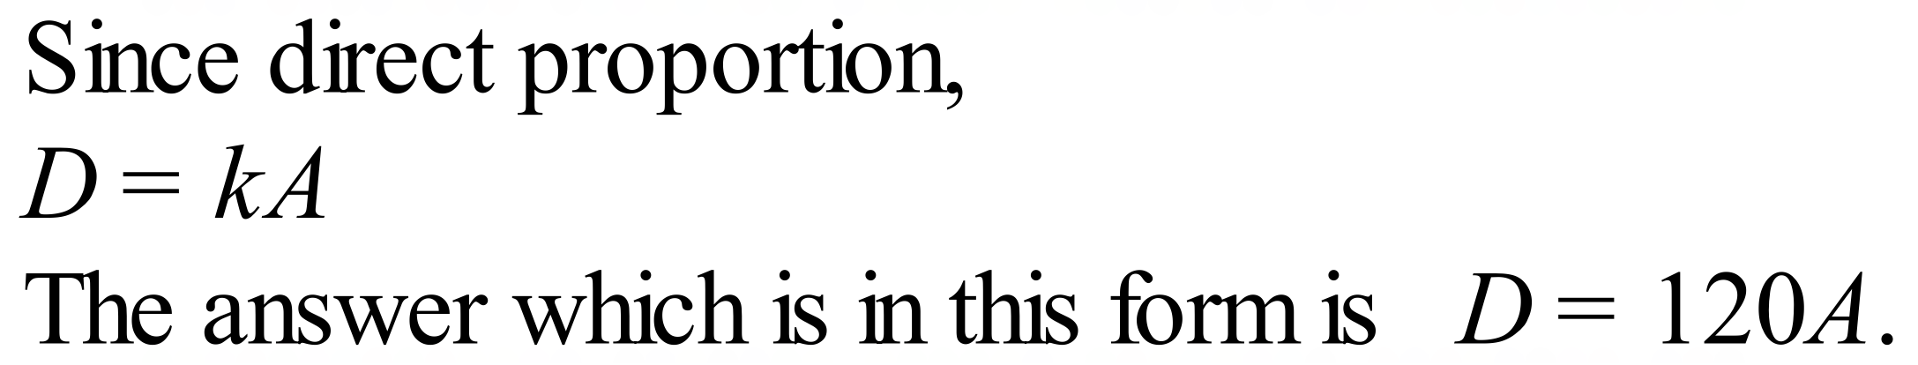 | B
 | 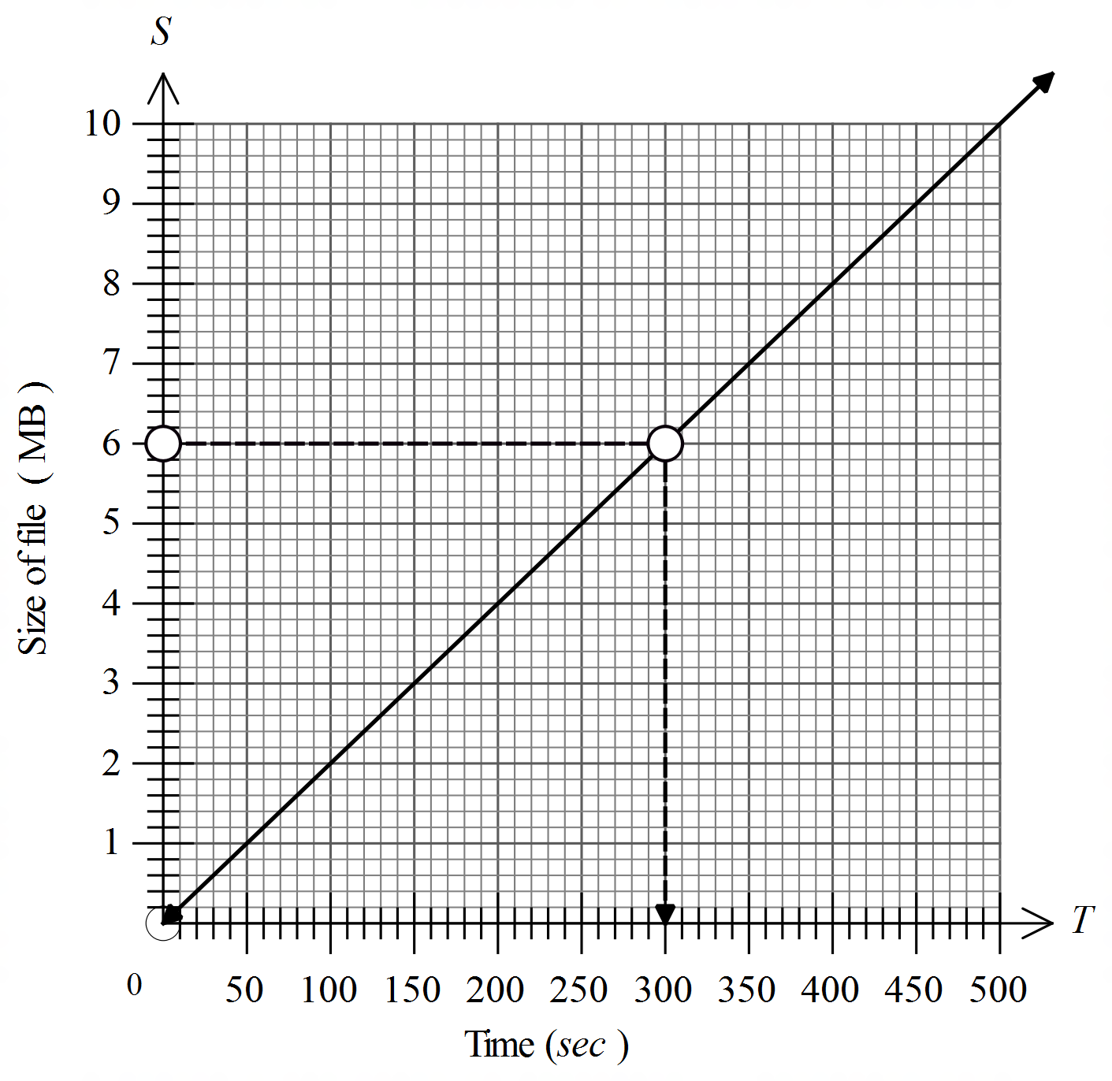  From graph, T = 300 gives S = 6. | D
 | 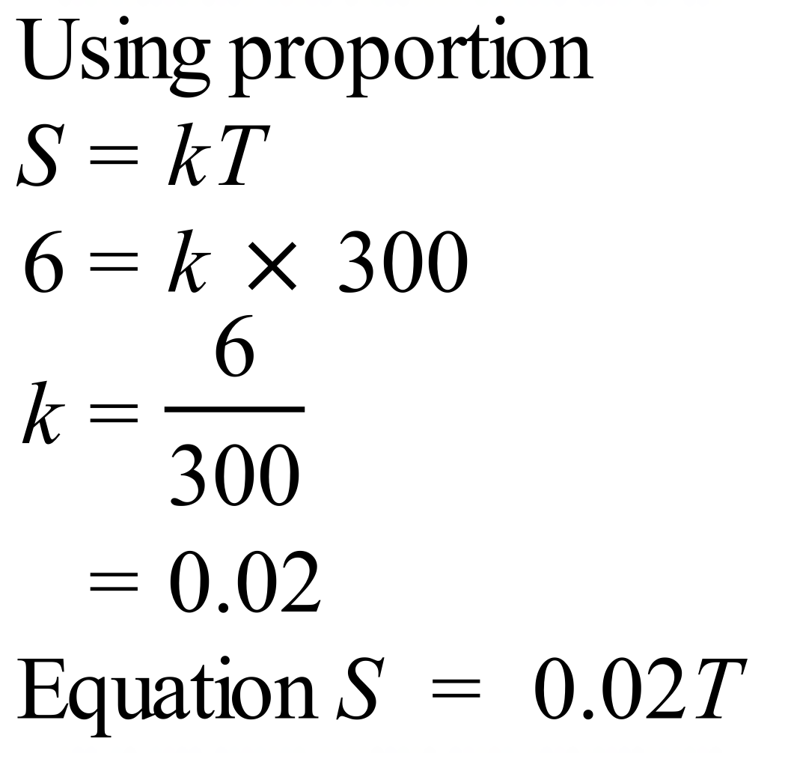 | A
 | Between 7:00 and 7:45 and between 7:45 and 8:30 the audience was increasing at a constant rate.  Between 8:30 and 9:00 the audience was decreasing at a constant rate.  Between 10:00 and 10:30 the audience the audience was decreasing at an increasing rate. | D
 | 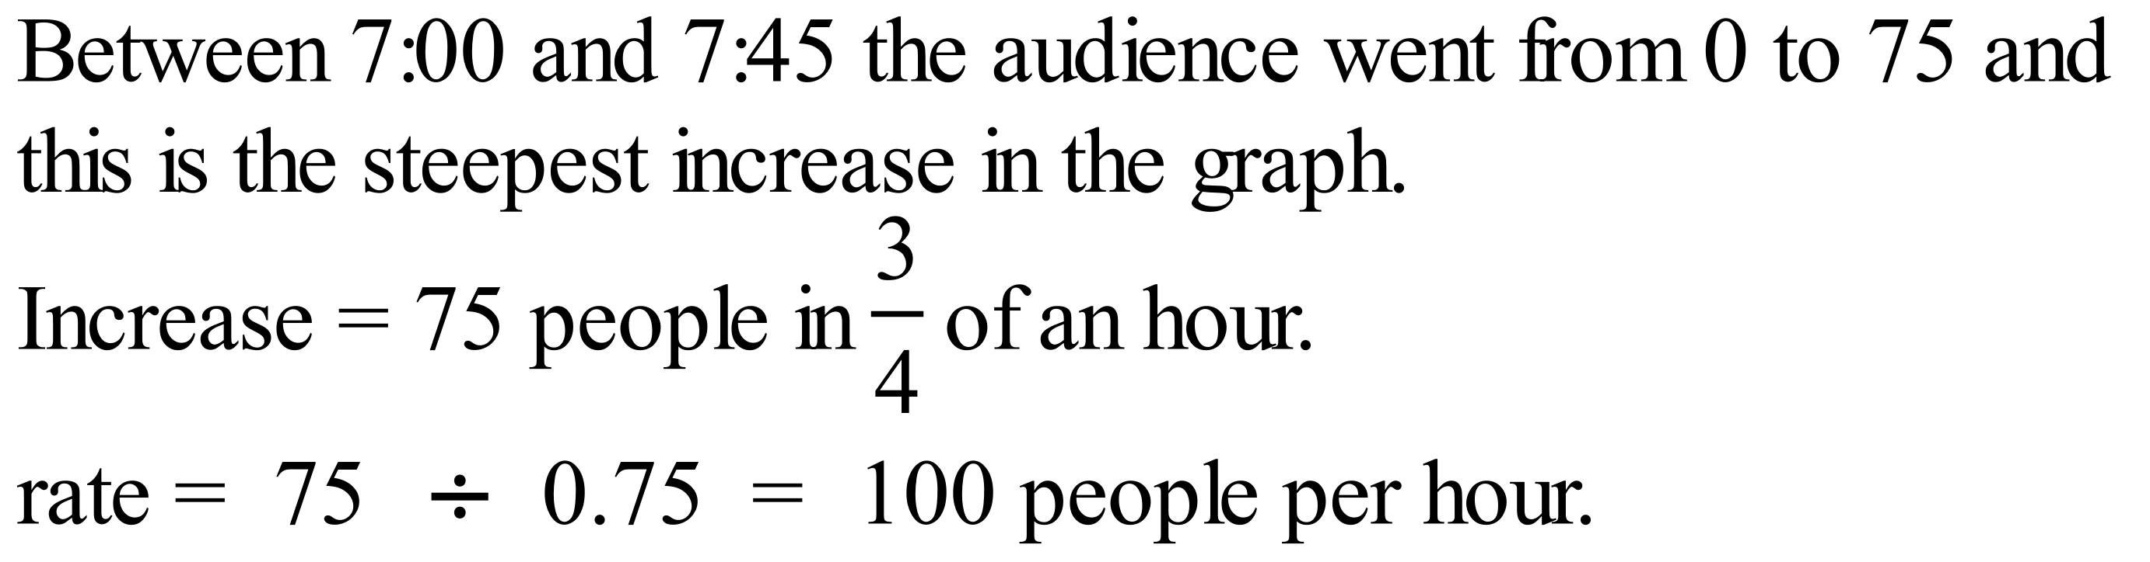 | C
 | She stops 3 times and the second stop is the shortest, 10 am to 10:30, so ½ an hour and the 2nd stop is Ursula | B
 | 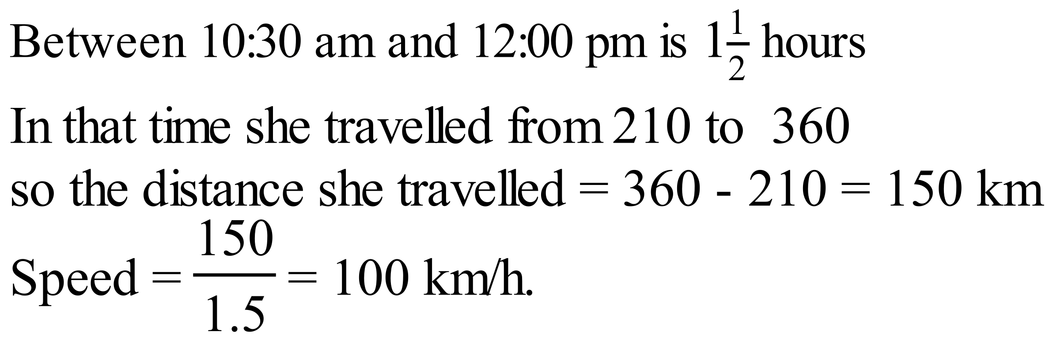 | D
 |  | C
 | Directly proportional so  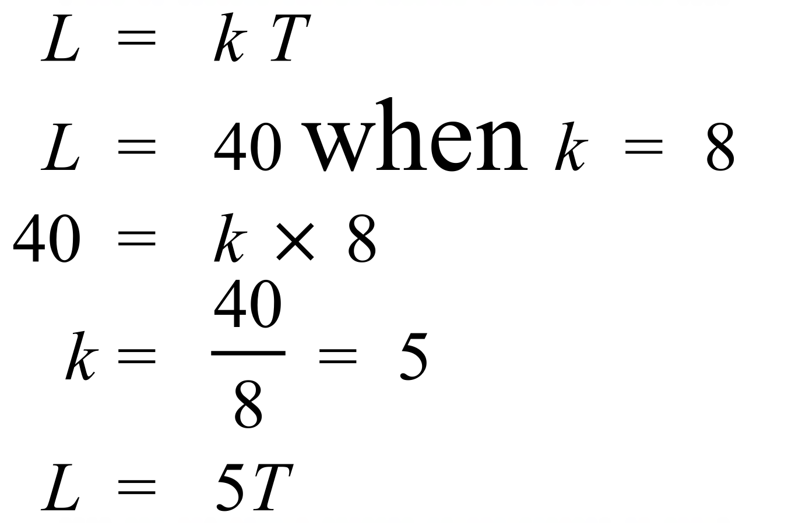 | C
 | P and Q are in direct linear proportion, so this indicates there is a straight-line relationship which starts at the origin. | D
 | Only A, B and C are decreasing relationships ( y is getting less as x increases).  A is decreasing at a decreasing rate as the slope of the graph is growing shallower as x increases.  B is decreasing at an increasing rate and C is decreasing at a constant rate. | A
 | 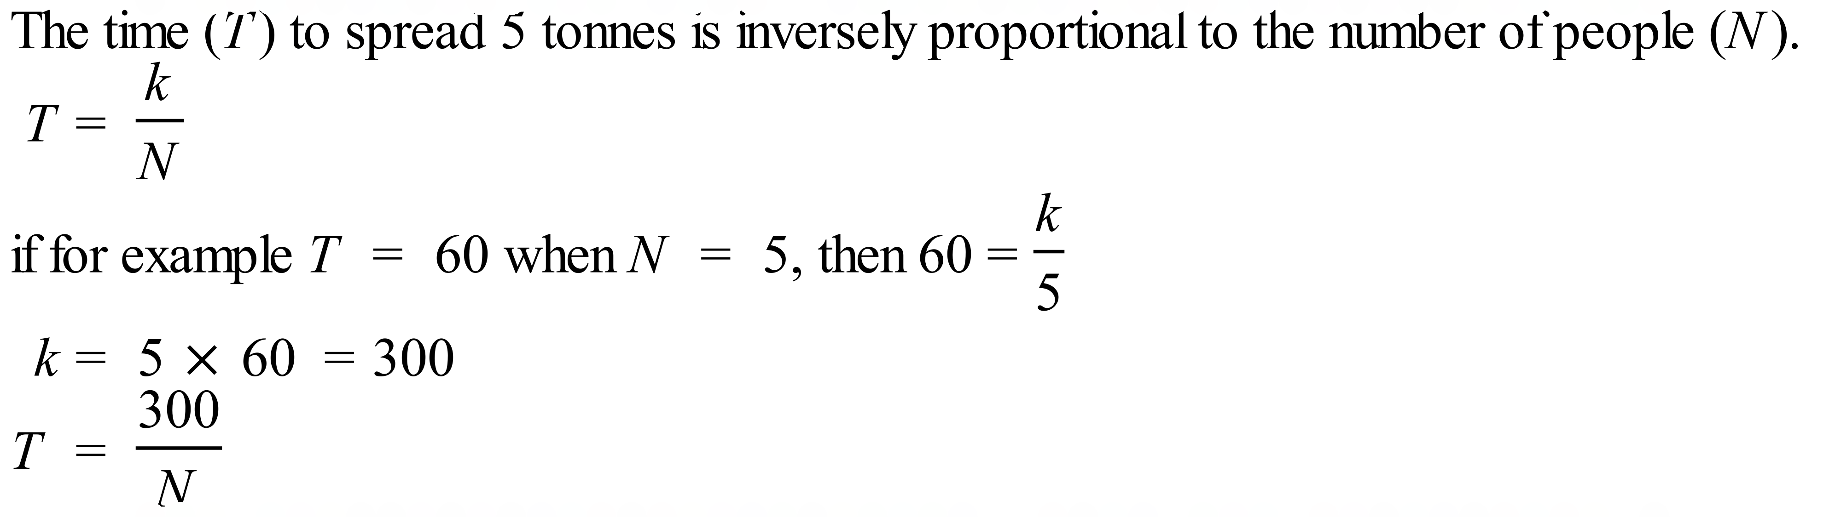 | B
 | The graph of L is going up as K increases, so is increasing.  The graph gets steeper, so the increase is at an increasing rate.  Increasing at an increasing rate. | D
 | 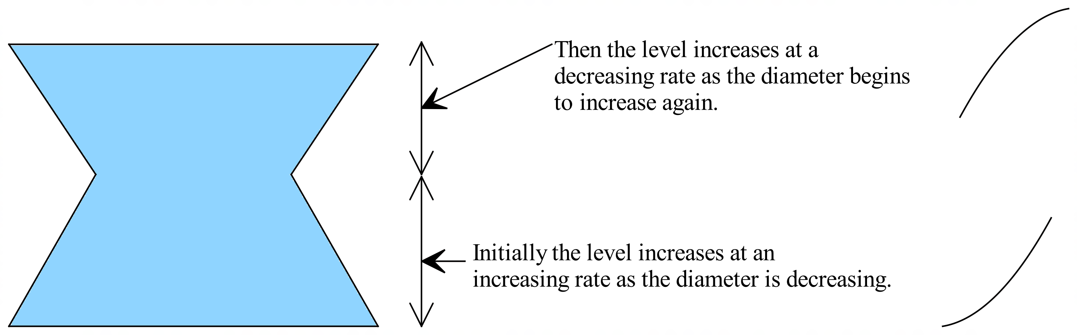 | A

School Name
Mathematics 2017
Multiple Choice Answer Sheet
Proportion
Name _____________________________________________
Completely fill the response oval representing the most correct answer.
1. A B C D
2. A B C D
3. A B C D
4. A B C D
5. A B C D
6. A B C D
7. A B C D
8. A B C D
9. A B C D
10. A B C D
11. A B C D
12. A B C D
13. A B C D
14. A B C D
15. A B C D

